**Online Exercises**

Explore 2000+ online exercises in 20+programming languages

**Training Videos**

Embrace a simpler and practical learning experience to enrich the tech-knowledge

**Online Quiz**

Test students’ skills and knowledge for interview readiness

**Guided Training**

Prepare them with our guided training and phy-gital workshops

**Soft Skill Sharpening**

Enrol with personality development sessions and soft-skill training for sharp first impressions during interviews

**Personalized Counselling and Placement Support**

Discover students’ potential with one-on-one sessions tailored to their career goals



## Watch your students graduate in style with a job offer in hand!

Sign us up as your Strategic EdTech Partner. Bring a reputation with glowing recommendations to your college. Embrace extracurricular additions such as interpersonal soft-skill training for extraordinary results.

### Build their solid foundation before picking a track

This is for entry-level grads testing waters and exploring multiple options in IT to explore various languages.

#### Choose their path based on the trial

Pick the right track based on Step One. Sign up for the bridge program

#### Watch them become the expert they want to be

Let them deep dive into the tech journey. Upgrade their soft and hard skills to get job ready.

## Want to become the most sought after college yet?

## Unemployment is not the issue. Unemployability of the human resources is.

By being part of the growth journey, aavanto puts together a personalized schedule to suit the student’s career aspirations as well as job market needs. Connect with us to know more

## The first ever learning platform with in-built advanced coding editor for self-motivated education, guided training and placement support.

byteXL enables guided learning and up-skilling over time. We supplement your students with soft and hard skills and groom them early on. Together, let's get them job-ready as they graduate

[Take the next step with aavanto](https://www.bytexl.com/pricing) tRT

### 10000+

paid subscriptions from students over 90+ colleges

#### 4000+

students placed in MNCs like Wipro, Infosys and TCS as of March - 2022

#### 1500+

students placed in top product-based companies with super dreamer and marquee offers as of March – 2022

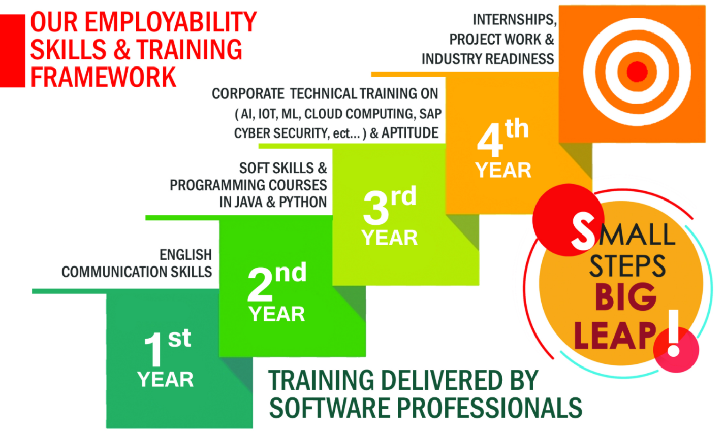

OUR HIRING PARTNERS



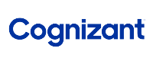







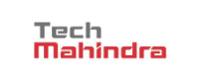





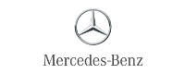



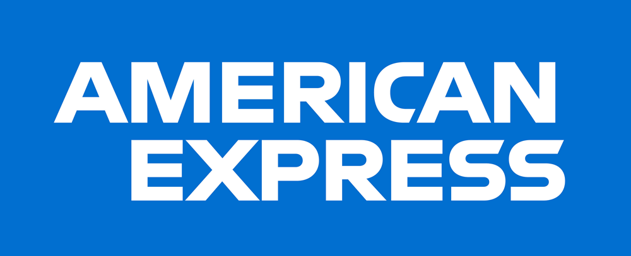























capgemini



